Evangeline N Nderu
WomanKind Kenya,
Garissa/Nairobi, Kenya

Through the Upper Midwest Human Rights Fellowship, I got the opportunity to work with WomanKind Kenya (WOKIKE). This is an organization founded in 1989 by a group of Somali Kenyan women who realized that an effective tool in the development of the North Eastern province of Kenya is the education and empowerment of women and girls. The organization has been particularly active in the areas of education and health, although their influence, as I discovered, goes far beyond the classrooms and the health centers that they have helped to build and develop.

WOKIKE is also an effective advocacy group. One of the achievements that the executive and program directors spoke of with justifiable pride was the constitutional review of Kenya, the delegation of which they were a part. They were instrumental in advocating for women’s rights and the recognition of women’s roles in the development of Kenya. They were vocal in their support of the education and development of Northeastern women and girls. WOKIKE has also been very active in the protest against Female Genital Mutilation at the national and international levels in Kenya. I was in awe of the two women that run WOKIKE, Sophia Abdi Noor and Hubbie Hussein, my supervisors and hosts.

I spent about half the time of my fellowship in Nairobi and the other half in Garissa, although I traveled into Ijara district to view the projects with some of the program officers. The first week in Nairobi was spent meeting with my supervisors, learning what they intended for WOKIKE and hearing what had been happening in the recent past in Kenyan politics. This was interesting as I have not been as in touch with the Kenyan political scene as I would have liked living abroad. It was also informative because it explained the expectations that people had regarding economic, professional and personal expectations. My supervisors explained what WOKIKE had achieved thus far, including the development of schools, dams and shallow water pans, and a home for female orphans [I learned that children who had either lost a father or both parents was considered an orphan]. Other initiatives undertaken by WOKIKE include capacity building and management training, animal husbandry initiatives and animal vaccination empowerment.

With the Somali Peace talks going on in Nairobi as well as other business that WOKIKE was involved in, it was difficult to connect regularly with my supervisors during the first week. So I spent a lot of that week at the offices of another advocacy organization, Niaje initiative. Niaje has as its main aim the establishment of entrepreneurship among youth in the Kibera slums of Nairobi. The Director of the program was happy to share information about Niaje and asked me to help hone a program that he wanted to establish, which encouraged youth to form ideas on potential businesses they could develop for themselves. They would be asked to take pictures in their neighborhoods and develop stories about them. From the pictures and with guidance from business councilors, they would be able to come up with ideas on small business initiatives that would potentially grow into sustainable businesses. We worked on this idea, contacting youth centers in the slum area and meeting with a few of them to finalize the activities. Towards the end of the week, the director asked me to start brainstorming ideas for sustaining this program beyond my stay in Kenya. As I had informed him that I had another project I was working on, we decided to continue correspondence electronically.

The beginning of week two was a whirlwind of activity. After getting a call on the Sunday night, asking that I get ready for a trip to Garissa, we set off early Monday morning. The trip was generally uneventful. The one thing that stood out was how dry the landscape was. In parts of Kenya, there has been no rain for months. This has resulted in drought and the declaration of famine in large sections of the north of the country. The famine proved to be one of the bigger detriments to my proposed project.

The intention of my internship with WOKIKE had been two-fold – to develop a gender-sensitive curriculum for the teachers in Ijara district and to help develop assessment tools of WOKIKE initiatives. The first was almost immediately abandoned mainly because many people in this part of the country are traditionally pastoralists. With the famine and drought, they had moved with their livestock in search of greener pastures [no pun intended]. Further, by the time I arrived, the school term was over and teachers were attending personal business usually several miles from the schools. Therefore the interviews of the teaching staff and examination of the school curricula that I had planned were impossible to conduct.

The second task was achieved in a manner of speaking. I and some of the WOKIKE staff spent time examining the assessment tools that they had previously used. They also had some data from several surveys that had been conducted assessing the usefulness of a program developed in conjunction with a small, grassroots women’s organization. WOKIKE wanted to ascertain that the establishment of the business was impacting not only the women directly involved, but was also significantly impacting the area in an economic sense: as an attraction that would encourage
visitors to stay in the lodging and conference rooms provided, and as a source of employment for the locals. The final analysis indicated that it was economically impacting the women’s group positively and they still had a ways to go to make more of an impact in the general community.
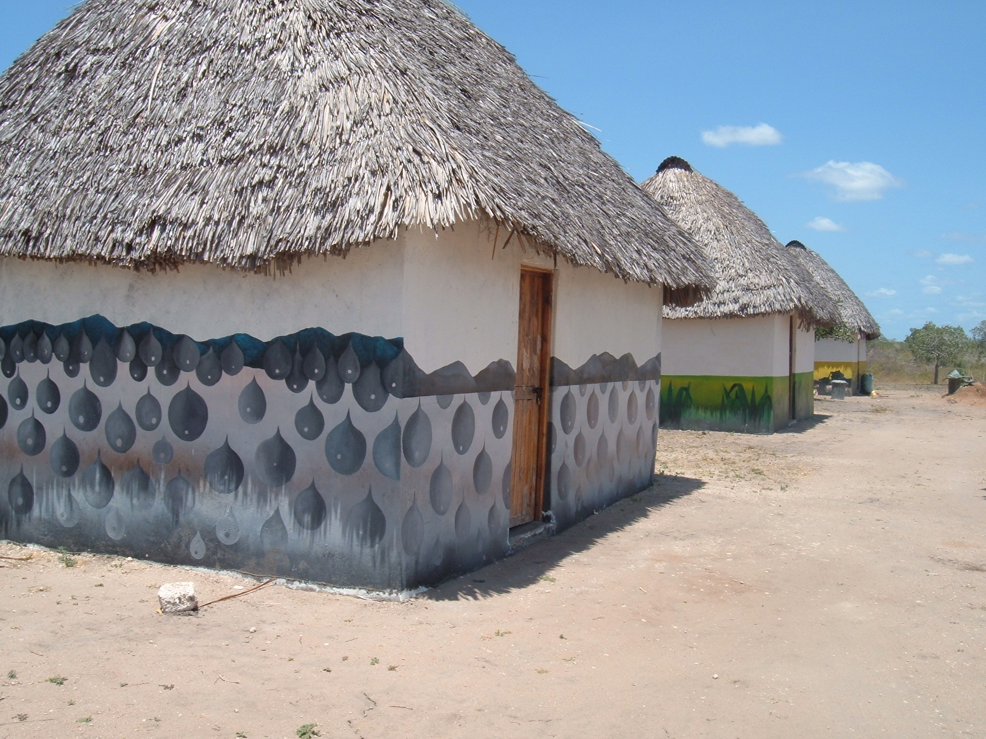
At left are three rooms of the lodging and conference area as developed by WOKIKE in conjunction with Balaa Women’s Group.

A second task I found myself involved in was grant writing for the organization. When I arrived, they were preparing a concept paper for Concern Universal. The foci for the grant were on water, health issues, sustainability and food security – all areas in which WOKIKE has been active. The days were mainly spent going through WOKIKE documents, looking for records of passed achievements in these areas, and going to the field with field officers ensure that established programs were being sustained by local communities as they should have been.

A large part of a non-profit organization, especially at the grassroots level is spent in fundraising efforts and grant writing. As soon as we had submitted the paper to Concern Universal, we began working on another proposal in collaboration with two other organizations, this time with a focus on education and health issues, particularly in HIV/AIDS prevention. The gathering of necessary information, submission to the local representative, adjustments and resubmission took the better part of ten days for three of us to accomplish. This was an invaluable lesson for me since I had never been involved in a grant-writing process from beginning to end at an organizational level. Whether they get the grant will be apparent in time …

The final task they set me was the development of brochure for the organization. At the time of this writing, the brochure is still in progress and will be returned to them by the end of September for their perusal.

Agency Placement:
I did not request housing from WOKIKE. While I was in Nairobi, I stayed at a two-star hotel that was accessible to the City by matatu (the local transportation) and bus. I had found the hotel through a relative that works and lives outside Nairobi and who had recommended it as a clean, safe abode for a woman traveling alone. In Garissa, the agency provided me with housing and transportation.

I first met the executive director and program director two to three days after I had landed in Nairobi. They were courteous and hospitable. It was not initially clear what they wanted me to do for their agency although they were in agreement of my proposal and were enthusiastic. When I finally met their employees, I was struck by the cohesion of the group and the great respect that they had for these women. Every one called them “Auntie” which is a respectful way of addressing an older woman or a woman in authority. The communication between the staff and the directors went both ways and they often asked their staff questions that would inform and educate them. They too, respected their staff asking them for advice in their areas of expertise.

Would you recommend that another person do a fellowship at the agency? In the area you were in?
Absolutely. My only reservation would be in remembering that communication in Kenya, particularly in the rural areas, is slower than we are used to in the United States. This is partially due to the lack of adequate infrastructure and partially due to cultural norms. In my case, communication was often frustrating when I was in the US. Email sometimes went unanswered and telephone communication was sometimes sketchy because of an inconsistent network system. When I arrived in Kenya though it was much better.

Generally I felt safe in Nairobi. Like any large city, one has to take precautions like not walking alone after dark, not wearing flashy jewelry, and always being conscious of what’s going on in the immediate surroundings. In North eastern province, the insecurity issues that were present a few years ago have been greatly reduced. I felt secure wherever I went and people were generally friendly and helpful.

The whole experience was worthwhile to me in that I felt that I understood the Somali culture much more than I had previously. I also got in to the workings of a grassroots NGO in Kenya and began to appreciate some of the barriers that they had to overcome as well as some of the ones that they are facing. On a personal level, this experience tested and strengthened my resolve to work in the Non-profit world in the future, and it was a good introduction to a human rights program at a hands-on level. Although there are hurdles, the kind of work and advocacy being carried out by organizations like WOKIKE is important to the development of the local girls and women, and by extension the region and country.

My contacts developed during this experience were also useful to me personally and professionally. It was important for me to get a different perspective of the lifestyle of the Kenyan Somali people. I also developed insights into development initiatives at the grassroots level. This information has informed some of my dissertation findings and calls for further investigation with a view to helping develop some of the existing initiatives in Minnesota that are designed to allow newly immigrated Somalis to make this State their home.

Organizational Profile
Full name of Organization: Woman Kind Kenya
I originally thought they were an affiliate of Womankind international, but they have no connection.

Abbreviation commonly used: WOKIKE

Organizational Address: P. O. Box 627, Garissa, Kenya
Tel: 046-2508
Fax: 046-3480
Email: wokike@wananchi.com

Executive Director: Sophia Abdi Noor
Program Director: Hubbie Hussein Al-Haji

Number of staff employed fulltime: 4

Number of volunteers: Not known

Objectives of the Organization: WOKIKE is an indigenous local NGO/nonprofit based in Garissa, whose mission is to support the most vulnerable members of communities in Garissa and Ilara districts (especially the women and children, the poor and destitute) so that they improve their standard of living through the attainment of knowledge and self-empowerment.

Date of information: September 17th, 2004
Information provided by: Evangeline Nderu

A common pastime in Kenya is discussing the political developments (or not) of the current government, how these developments will affect people on a personal or professional level, and how one would do things differently if one was in a similar position.

